Computer Language Coding Concepts

Names of Related Items & Related Lists
Every related item and related list has a name. This names counts in the context of the parent object. The name is not assigned to the object, but to the related item ore related list. The system objects related item and related list get a Name member. So the system interfaces of related items and related lists get a Name member.
The diagrams below show a Name member inside the system interface of a related item and a related list.

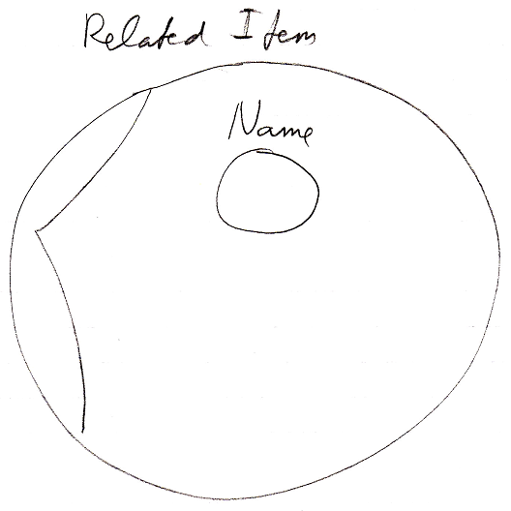

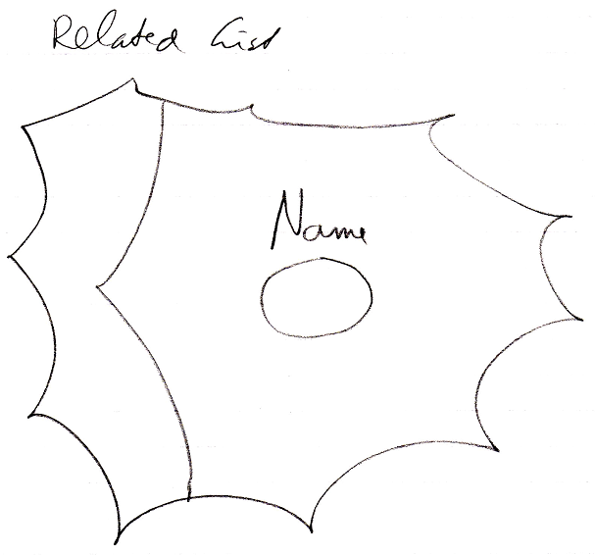

See also: System Objects, Related Item, Related List

Author & Copyright: Jan-Joost van Zon Date: July 24, 2008 – July 24, 2009 Location: Oosterhout, The Netherlands Status: Finished

